**Brooklyn torah gazette**

**For parshas vayelech 5783**

Volume 7, Issue 2 (Whole Number 309) 6 Tishrei 5783/ October 1, 2022

**Printed L’illuy nishmas Nechama bas R’ Noach, a”h**

For a free subscription, please forward your request to [***keren18@juno.com***](mailto:keren18@juno.com)

Past stories can be found on the website **ShabbosStories.com**

**Rav Mordechai Gifter, Zt”l**

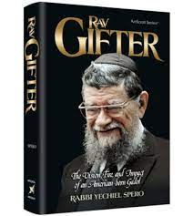

Rav Mordechai Gifter, son of Reb Yisroel, zt”l, was born on 7 Cheshvan, 5676 (1915) in Portsmouth, Virginia. Throughout his life he frequently referred to his father’s love of Torah and outstanding character traits, especially noting his integrity. Due to the difficulty of educating his children in Virginia, Reb Yisroel moved his family to Baltimore, which at that time was one of the Torah centers of the United States.

HaRav Gifter grew up there. When HaRav Gifter was young, HaRav Shimon Shkop visited Baltimore in order to strengthen the Grodno yeshiva of Lithuania. HaRav Gifter’s father took him to receive a brocho from the “kohen hagodol,” HaRav Shimon Shkop, who blessed him that he would become a godol beTorah.

HaRav Gifter later attributed his success in Torah to HaRav Shimon Shkop’s brocho. He was outstanding in his hasmodoh even as a youth, and known for his extensive knowledge and remarkable memory, to the point that he was like a “bor sod she’eino me’abeid tippoh.” While still young, he became known in the Torah world as a rare illui and it was expected that he would one day illuminate the yeshiva and halocho world with the light of his Torah.

**His Mentor was Rav Yitzchok Soloveitchik**

Affirming this is the fact that when he was only fifteen years old, his chiddushim were published in the Toras Eretz Yisroel journal printed in Petach Tikvah, alongside the Torah writings of HaRav Tzvi Pesach Frank and HaRav Reuven Katz. As a youth, he studied in the Rav Yitzchok Elchonon Yeshiva of New York City under his rav, HaRav Moshe Halevi Soloveitchik, whom he regarded as his mentor, chiefly in the foundations of derech halimud.

HaRav Gifter often related: “My mentor’s shiurim were mainly derived from his father, the Grach HaRav Chaim Halevi Soloveitchik and those were what he called `pshat.’ Only rarely would he relate his own Torah ideas. Sometimes he would say: `Now we will say some Torah,’ everyone knew that then he intended to recite his own thoughts and explanations.”

HaRav Gifter studied together with HaRav Nosson Wachtfogel, zt”l, former mashgiach of Lakewood and HaRav Avigdor Miller, in the Rav Yitzchok Elchonon Yeshiva, where HaRav Gifter made great strides in Torah. During bein hazmanim when he returned to his parents’ home in Baltimore, he would continue to pore over his studies with tremendous hasmodoh. During the hot summer months, he would sit on his porch and memorize masechtos.

**Demanded that His Student Learn**

**Mesechto by Heart During Bein Hazmanim**

He also later demanded that his students learn masechtos by heart during bein hazmanim, quoting the introduction to the sefer Beer Sheva, whose author had similarly instructed his students. On this issue, he related that on his way to the Telz yeshiva in Lithuania, he had passed through Slobodke, where he stayed for a brief period.

Upon his arrival in Slobodke, the rosh yeshiva HaRav Eizik Sher asked him: “What have you studied lately?”

“Me’ilah,” the young HaRav Gifter replied.

HaRav Sher rebuked him, and said: “Have you completed Bovo Basra and Bovo Kamo?”

When HaRav Gifter told HaRav Sher that he had studied Me’ilah during bein hazmanim, HaRav Sher praised him highly. It was on the advice of his uncle, HaRav Yehuda Leib Zer, one of the directors of the Rav Yitzchok Elchonon Yeshiva, that HaRav Gifter went to study in the Telz yeshiva of Lithuania in the winter of 5692 (1932).

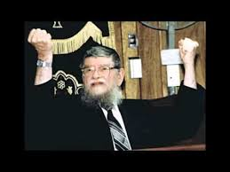

When he arrived, he was received by the rosh yeshiva, HaRav Avrohom Yitzchok Bloch, Hy”d, who instantly discerned that HaRav Gifter was an outstanding student, destined for greatness. HaRav Bloch immediately placed him in a group with the best students. From then on, a strong bond was formed between HaRav Bloch and HaRav Gifter, who regarded HaRav Bloch as his rav muvhak. In his shiurim, HaRav Gifter often quoted HaRav Bloch, saying: “I heard from mori verabi.” In his writings, he also referred to HaRav Bloch as: “Mori verabi, the admor hakodosh, Hy”d.”

HaRav Gifter often spoke about the rischa deOraisa prevailing in the Telz yeshiva of Lithuania. When HaRav Gifter first arrived in Telz, the yeshiva was filled with hundreds of students studying with indescribable simcha and fervor. The young Rav Gifter noticed one student whose simcha was especially conspicuous. When he asked who this student was, he was told that he was the poorest bochur [in comprehension] in the yeshiva.

HaRav Gifter would always tell his students that Torah must be studied out of simcha, and would often quote the words of Reb Avrohom Minhahar on the gemora in Nedorim 48, that the simcha of Torah study is one of the main aspects of the mitzvah of talmud Tora {Shema Yisroel/Matzav.com}

*Reprinted from the Parshas Nitzavim 5782 email of Reb Yedidye Hirtenfeld’s whY I Matter parsha sheet for the Young Israel of Midwood in Brooklyn, NY.*

**Utilizing the Power of “Hakhel” To Create an Atmosphere of Togetherness to Uplift Other Jews**

**From the Talks of the Lubavitcher Rebbe**

**Rabbi Menachem Mendel Schneerson, Zt”l**



In this week's Torah portion, Vayelech, we have the commandment of Hakhel. "Assemble the nation, the men the women, the children... In order that they hear and in order that they learn and revere G-d... and will be careful to do all the words of this Torah."

Hakhel took place on Sukkot in the year after the Sabbatical year. All the Jewish people would assemble in the Holy Temple. The king, standing on a podium built for the occasion, would read selections from the Torah for all to hear.

While most mitzvot connected to the Temple are not done today, Hakhel is unique in that at least parts of it can be done, and not just in a "Hakhel" year. Though we currently have no king and no Temple (may it speedily be rebuilt) but the reasons, "in order that they listen, learn, revere and do," can still be implemented.

The prerequisite is that you are "assembled," meaning all of you are in a state of togetherness, with brotherly love. "Togetherness" sets the mood and opens the heart to hear words of meaning and chizuk (strengthening), "in order that they hear..."

When I started to lose my ability to speak, it made me much more aware of the power of speech. I had to decide what is truly worth saying. Now, unable to speak, I dream of what I would tell my family with my own voice if I could.

Words are powerful, when used correctly they can lift up a spirit, when abused, they can destroy.

Our children, spouses, and other relatives ache for our recognition and love. Especially during the holidays, when we spend so much time together, we need to make sure to use words that uplift and bring others close with love and kindness.

Our families value our words and remember them. Your actions are equally, if not, more important. Create a loving atmosphere, focus your attention on them. Listen to what they have to share with you. They want you to know them, and to be proud of them.

When you have set a loving atmosphere, then you can discuss G-d, Torah and mitzvot. Their ears and their hearts will be open to hear and to learn, to revere G-d and to keep His Torah.

Consider making a get together with your family and friends. Create an atmosphere of togetherness, speak to their hearts with love and kindness, make them feel "most important."

*Adapted by Rabbi Yitzi Hurwitz from the Rebbe's teachings, yitzihurwitz.blogspot.com. Rabbi Hurwitz, who is battling ALS, and his wife Dina, are emissaries of the Rebbe in Temecula, Ca.*

*Reprinted from the 5780/2019 Parshas Vayelech edition of L’Chaim Weekly, a publication of the Lubavitch Youth Organization in Brooklyn.*

**Rav Avigdor Miller on**

**The Purpose of Life**



**QUESTION: What would you say is the purpose of this world?**

**ANSWER:** Now this world, we have to realize, was made for the purpose of having pleasure.  One of my great rebbes zichrono livracha – I remember it like yesterday in Slabodka – he was saying as follows; the first words of the Mesilas Yesharim. Pay attention.  העולם לא נברא אלא להתענג על השם – The world was made only for the purpose of enjoying the pleasure of Hashem. Now where is that? In the next world.  That’s how everybody learns pshat. The world was made להתענג על השם, to have pleasure from Hashem in the next world.  We prepare here, la’asos, for the pleasure in the next world.  That’s the plain meaning.

But there’s another meaning, also true.  העולם לא נברא אלא להתענג – The world was made only for pleasure. Stop. It’s absolutely true. Tzaddikim don’t like that.  Pleasure?  Pleasure in the next world, yes.  They’re not tzaddikim, though.  A tzaddik has to understand that Hakodosh Boruch Hu made this world for pleasure.

It’s such a good world that the Mesilas Yesharim in one place works hard to convince us that this is not the final place.  You hear that? We think it’s a waste of time.  He spends time convincing us this world is not the final place.  He proves it because you’re not here forever.  It comes to an end.  Sometimes there’s unhappiness.  We’re surprised at him!  העלה על הדעת, who would think this is a final place?

But he knew the world is such a happy place; life is very sweet!  It’s so good to be alive!  It’s such a great pleasure to be alive.  The ta’anug of Olam Hazeh! And therefore there’s a possibility of making the error of thinking, that this is it.  He says, “No.  There’s a bigger pleasure than here.”

Now people not accustomed to thinking about this won’t appreciate that.  You have to spend part of your lives studying the subject, how good this world is.  You have to study that.

*Reprinted from the September 11, 2022 email of Toras Avigdor (Tape #E-262 – January 2001).*

**19TH Century Miniature Prayer Book from Pisa**

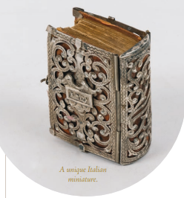

*Reprinted from the Fifth Judaica Auction of the TAJ Art Catalogue (Jerusalem)that was held in Jerusalem on September 13, 2022*

**The Chester Alan Arthur Story: Failure or Inspiration?**

**By**[**Rabbi Pinchas Landis**](https://aish.com/authors/575659791)

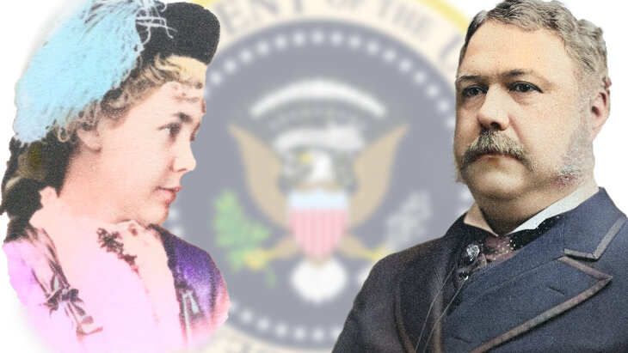

*Some rank Chester Alan Arthur as one of the worst presidents of all time. I think his life story is exactly what we need to hear this Yom Kippur.*

For inspiration, many people look with reverence at the founding fathers like George Washington, John Adams, and Thomas Jefferson. [Abraham Lincoln](https://aish.com/abraham-lincoln-and-the-jews-10-fascinating-facts/), Woodrow Wilson, and Franklin Roosevelt led the nation in times of peril. [Harry Truman](https://aish.com/why-harry-s-truman-recognized-the-state-of-israel/) and Teddy Roosevelt made tough decisions at crucial crossroads.

I look towards Chester Alan Arthur, the 21st President of the United States, for inspiration. Even though some pundits rank him as one of the worst presidents, a leader who wasn’t even technically elected to serve in the White House, I believe his life story conveys a number of great lessons that are particularly relevant as we gear up for [Yom Kippur](https://aish.com/yom-kippur/).

**Corruption Rules**

Arthur found himself on the map of American history at a tumultuous time. Besides the challenges of putting the country back together after the Civil War, the country was plagued with a corruption that had been in existence since the founding of the republic and had grown worse with time.

*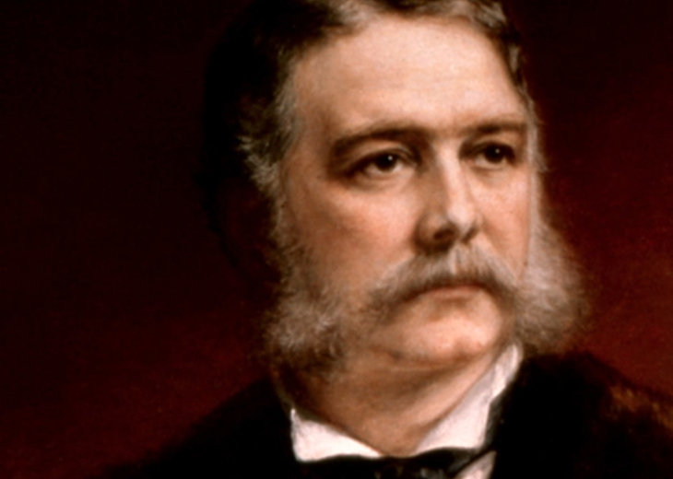*

***Chester Alan Arthur, the***

***21st President of the United States***

The Federal Patronage System (or Spoils System) endorsed political appointments as a reward to those who kept the party’s political machine going, regardless of one’s ability. Many Presidents had been elected on a platform to reform the Spoils System, but none had been able to stand up to those who helped propel them into office.

In 1869, Americans thought they were going to finally turn a corner with the election of Civil War hero General Ulysses S. Grant, who many viewed as another George Washington. Instead, they got eight of the most corrupt years of the American Presidency. Grant was followed by Rutherford B. Hayes who tried to reform the Spoils System but ultimately proved successful at only one thing, further dividing the Republican party.

At this time, the Republican party was deeply divided on the issue of patronage. The Stalwarts, led by New York Senator Rosco Conkling, wanted to keep the patronage system in place, and the Half-breeds vowed to reform the country. The internal rift boiled over at the Republican National Convention of 1880. In the days before binding primary elections, the convention alone would choose the presidential candidate, and 14 men were vying for the nomination.

**A Surprise Win**

The Stalwarts backed Ulysses S. Grant for an unprecedented third term. They felt that his image had been somewhat rehabilitated over the past four years and that he was once again electable. The Half-breeds backed Maine Senator James Blain. Secretary of the Treasury John Sherman, brother of William Tecumseh Sherman, was also considered a front runner. 379 votes were needed to win.

**On the 36th ballot, Garfield received 399, clinching the nomination that he did not want.**

On the first ballot, Grant got 304, Blain got 284, and Sherman got 93. On the second ballot, James A. Garfield, the congressman from Ohio, received one vote even though he had not been nominated. The balloting continued, with 33 ballots done over several days without any major changes. On the 34th ballot, a dark horse started to emerge from the pack – Garfield got 17 votes! He immediately challenged the legitimacy of this as he did not seek the nomination. His challenge was overruled by the chairman, who secretly supported his candidacy.

On the 35th ballot, Garfield received 50 votes, and on the 36th ballot, he received 399, clinching the nomination that he did not want.

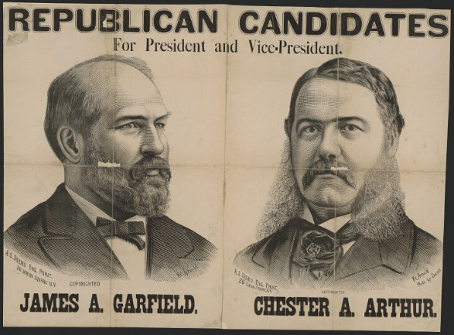

Conkling, the Stalwart leader, was livid at what had transpired. The Republicans knew that they needed to show a united front to beat Democrat Winfield Scott Hancock in the general election, so they nominated one of Conkling’s protégés as Vice President, Chester Alan Arthur. Arthur was a true Stalwart who had lined his pockets for years through the Patronage S ystem. The only position that he had previously held was Collector of the Port of New York, a job built for the crooked politician.

The general election had the largest voter turnout ever recorded at 78.4%. The Republican ticket won the popular vote by just 7,018 and an electoral college victory of 214 to 155. After the inauguration, Vice President Arthur worked in vain to secure cabinet positions for his cronies, but President Garfield made it clear from the beginning that he would work towards reforming the Civil Service. He did not appoint a single Stalwart to his cabinet.

Senator Conkling quickly butted heads with the president, and in a power play, he resigned from the evenly divided Senate, leaving Garfield’s appointments in peril, and fully expecting to be reappointed to his position by the New York State Legislature. During the summer recess of 1881, Conkling and Arthur returned to Albany to make this happen. In the end, Conkling had overplayed his hand, and New York chose another.

**Presidential Assassination**

*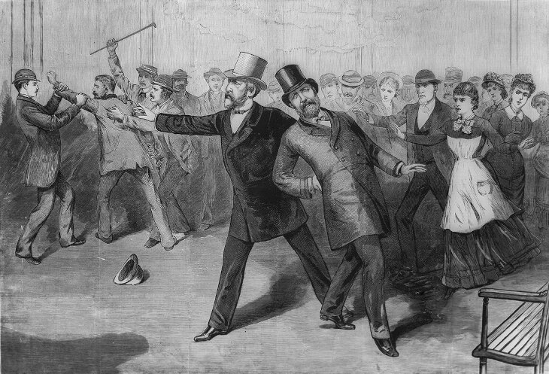*

On July 2, 1881, the Spoils S ystem motivated Charles J. Guiteau, a deranged evangelical preacher who thought that he deserved to be Ambassador to France, to shoot President Garfield after not gaining an appointment. After shooting the President, Charles J. Guiteau boasted, “I am a Stalwart, and Arthur will be President!” In his delusion, he expected to be broken out of prison by Ulyssys S. Grant’s militia, and to then received his anticipated appointment.

**In his wildest dreams, Arthur never imagined that he could be the president and he felt unfit for the task.**

For two months Garfield lingered between life and death. During that time, save the first lady, there was no one more distraught over Garfield’s predicament than Chester Arthur. In his wildest dreams, he never imagined that he could be the president, and he felt unfit for the task. There were even those who suspected Conkling and Arthur of being involved in the plot. At 2:15 a.m. on September 20, 1881, Chester Alan Arthur became the 21st President of the United States.

The assassination of Garfield achieved what 15 years of reconstruction had not been able to. The country was unified, and surprisingly, their new President rose to the occasion. President Arthur refused to follow the demands of Conkling, understanding the disgust of the American people with the Spoils system and how they blamed it for the beloved Garfield’s death.

**A Fierce Reformer and a Changed Man**

Arthur was a changed man. Swearing off the corruption of his past, he became a fierce warrior for reform of the Social Service. On January 16, 1883, Arthur signed the Pendleton Civil Service Reform Act into law. In just two years' time, an unrepentant Stalwart had become the president who ushered in long-awaited civil service reform.

What gave President Arthur the strength to turn his back on all that he had known to take the more difficult path of doing what was right?

In 1958, Chester Alan Arthur III, President Arthur’s grandson, sold his grandfather’s papers to the Library of Congress, and some light was finally shed on what motivated the change in Arthur.

In his papers, there were letters from a New Jersey lady named Julia Sand. The first letter dated August 27, 1881 read:

*Your kindest opponents say 'Arthur will try to do right' – adding gloomily – 'He won't succeed though making a man President cannot change him.'…But making a man President can change him! Great emergencies awaken generous traits which have lain dormant half a life. If there is a spark of true nobility in you, now is the occasion to let it shine. Faith in your better nature forces me to write to you – but not to beg you to resign. Do what is more difficult & brave. Reform! It is not proof of highest goodness never to have done wrong, but it is proof of it, sometimes in one’s career, to pause & ponder, to recognize the evil, to turn resolutely against it…. Once in awhile [sic?] there comes a crisis which renders miracles feasible. The great tidal wave of sorrow which has rolled over the country has swept you loose from your old moorings & set you on a mountaintop, alone.*

Sand went on to write 23 letters to the President, cheering him on when he did what was right, and calling him out when he fell short. In her year of writing the President, Julia Sand never got a response.

On the evening of August 20, 1882, she received an unannounced visitor at her home, President Chester Alan Arthur! He came to thank her for being his moral conscious over the tumultuous previous year.

**The Prostitute’s Words**

The Talmud ([Avodah Zarah 17a](https://www.sefaria.org/Avodah_Zarah.17a?lang=he-en&utm_source=aish.com&utm_medium=sefaria_linker" \t "_blank)) tells us of a man named Elazar Ben Dordaya who was so debased that he had visited every prostitute known to him. One day, in the middle of the act with such a woman, she spontaneously stated that Elazar Ben Dordaya will never change his ways. Her words – a prostitute – shook him to his core. He subsequently went outside, looking for somewhere to place his blame1 and finally concluded that if he was going to change, it would only be through his own actions. He then literally cried his soul out until he passed away.

At that point, a voice from Heaven announced that Rebbi Elazar Ben Dordaya is destined for the World to Come.

**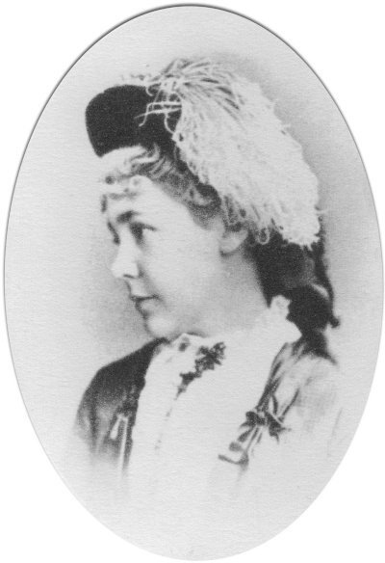**

**Julia Sand**

The presidency of Chester Alan Arthur echoes this story of repentance. If he had kept on the path he was on, his term would likely be remembered as more corrupt than that of Ulysses S. Grant. But his moral consciousness kicked in, spurred from the most unlikely of places, turning him into a president that ushered great reforms. This is why I find President Arthur so inspiring.

But there is another lesson here. Julia Sand wrote letters to a man whom she had never met, without knowing if her letters were even being received, much less read. She literally changed the course of American history.

As we head into this [period of *teshuva*, repentance,](https://aish.com/the-german-presidents-stunning-act-of-repentance/) let us all take the lessons of this inspiring story. We all have the ability to change – no matter how big or how small we are, and no matter what our past has looked like.

And we all have the ability to change the world, like Julia Sand. We just have to act and do what we can.

The historical accounts in this article are based on the books [*The Unexpected President: The Life and Times of Chester A. Arthur*](https://www.amazon.com/Unexpected-President-Times-Chester-Arthur-ebook/dp/B06XR93QXH/friendsofaishhat)and [*Destiny of the Republic: A Tale of Madness, Medicine and the Murder of a President*](https://www.amazon.com/Destiny-Republic-Madness-Medicine-President/dp/0385526261/friendsofaishhat)

1. According to the explanation of R’ Chaim Friedlander

*Reprinted from the September 25, 2022 website of aish.com*